**Movie News Bot**

**Here’s how bot works.**

Using Twitter API get methods bot search all **news, tweets, news about movie trailers with links** from famous movie news providers such as rottentomatoes, IMDb etc. Every 24 hour he does this.

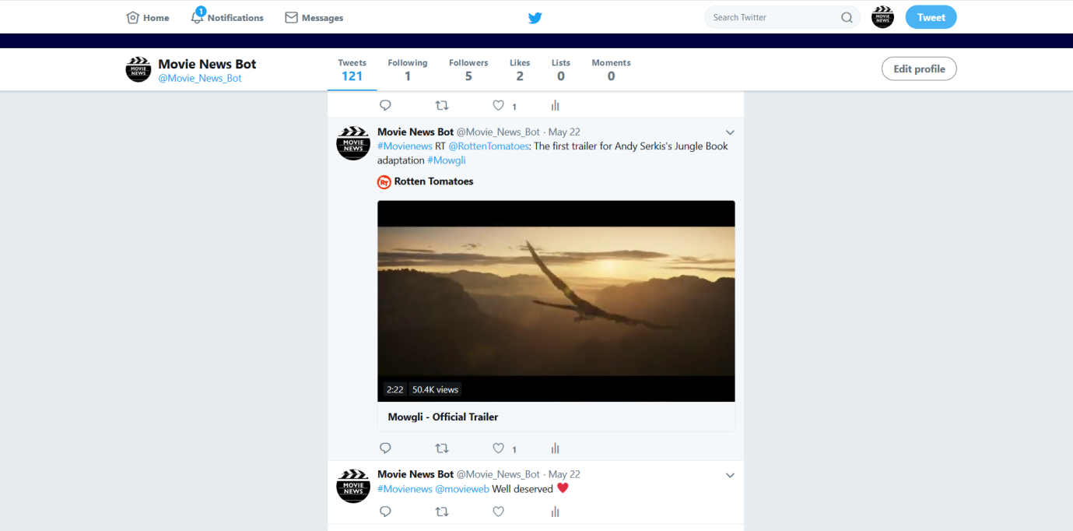

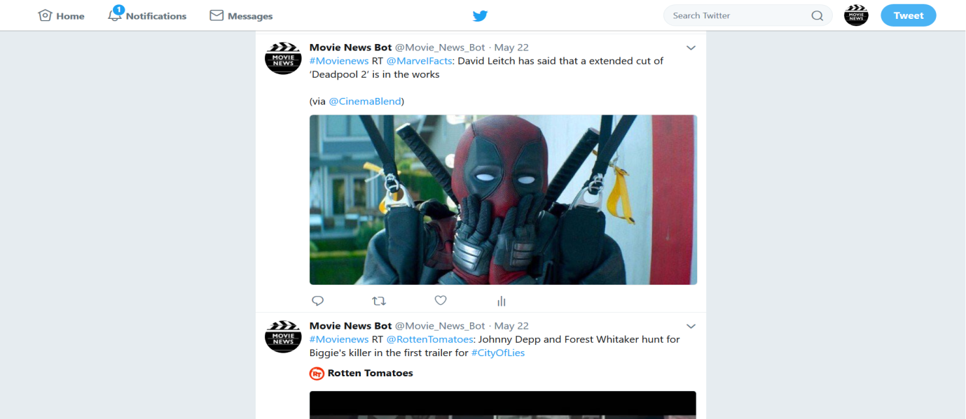

And also using stream function bot can listen to events such as liking,following. When such event happen he will retweet at him.

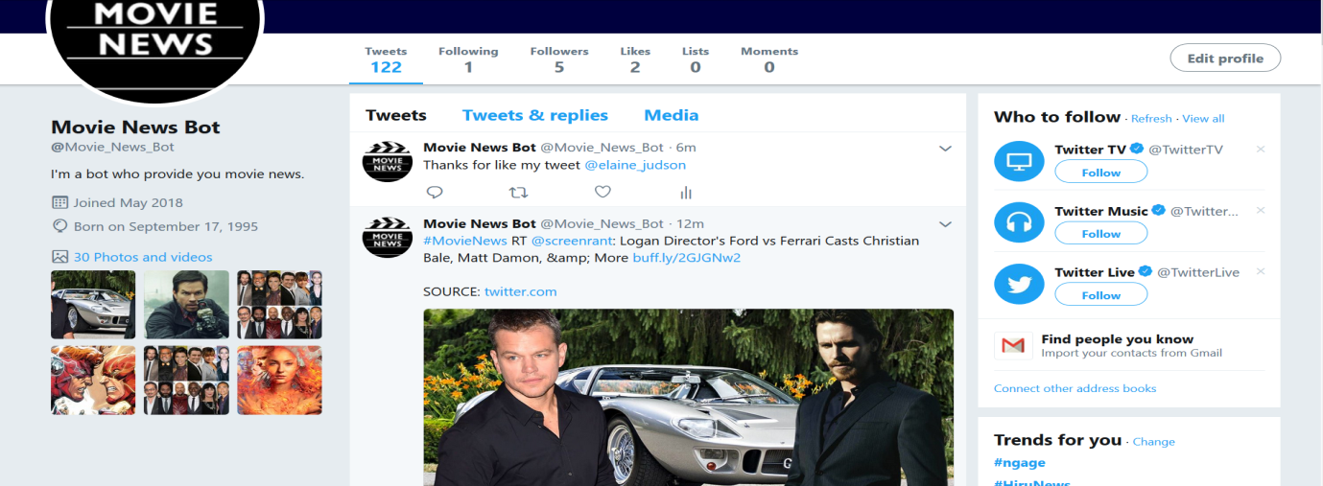

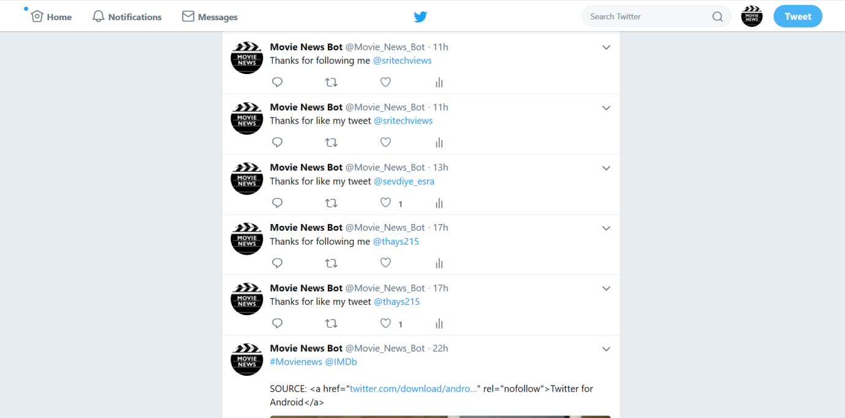

And also app has deployed in heroku.

